Practice Test. Part2.

41.

42.

43.

44.

45.

47.

48.

49.

50.

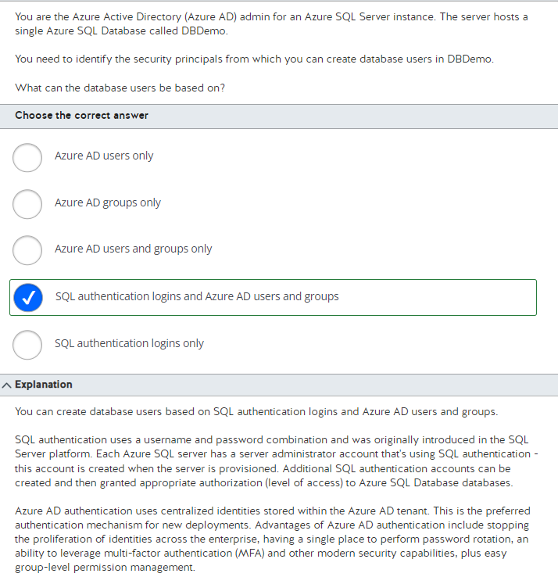

51.

52.

53.

54.

55.

56.

57.

58.

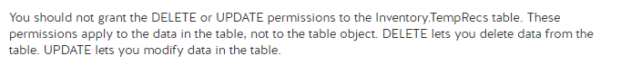

59.

60.

61.

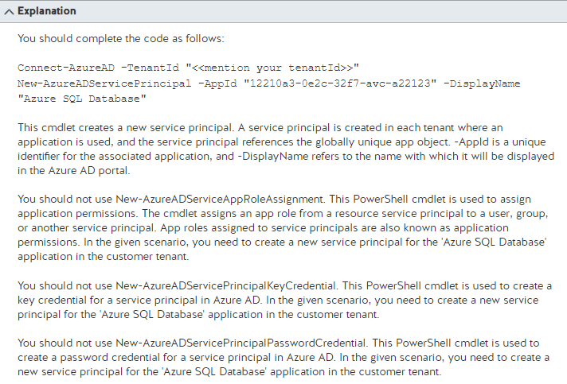

62.

63.

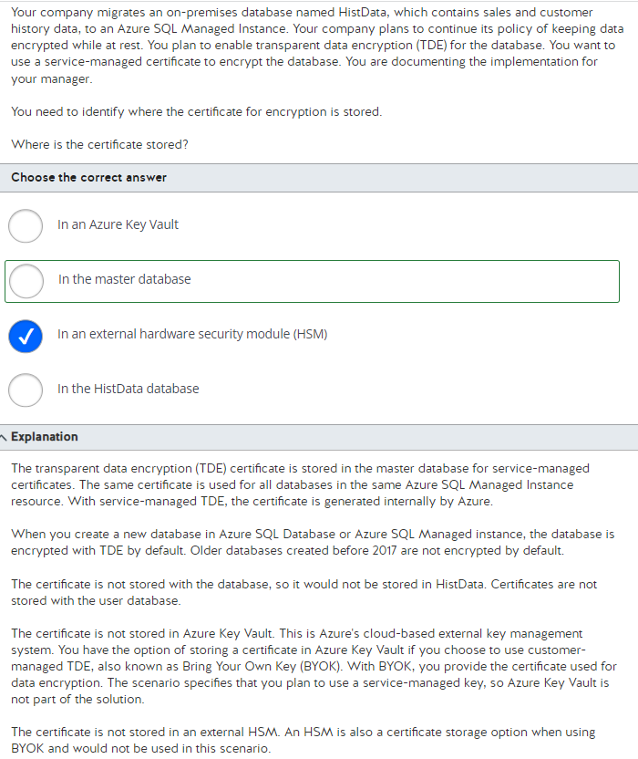

64.

65.

66.

67.

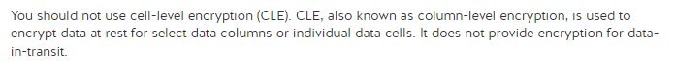

68.

69.

70.

71.



72.

73.

74.

75.

76.

77.

78.

79.

80.

